**Data Structures and Algorithms**

**Lab report: 13**

|  |  |
| --- | --- |
| **Name:** | **Ali Salman** |
| **Reg no:** | **FA22-BCE-005** |
| **Class:** | **BCE-3A** |
| **Lab Instructor:** | **Dr. Ali Mustafa** |

**Lab 13 Implementation of Graphs in C language**

**Task 1:**

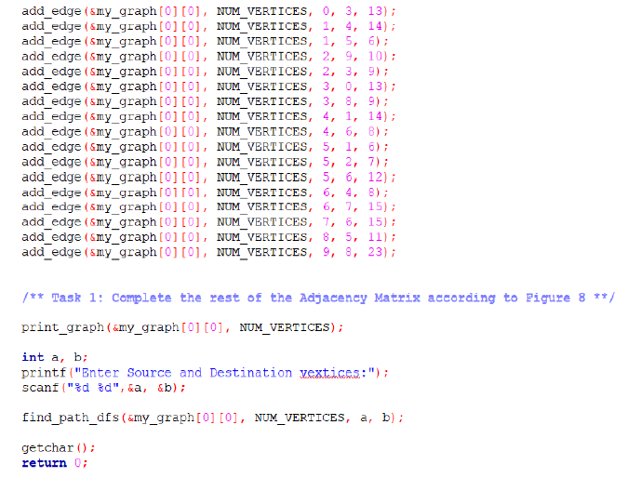

**Task 2:**

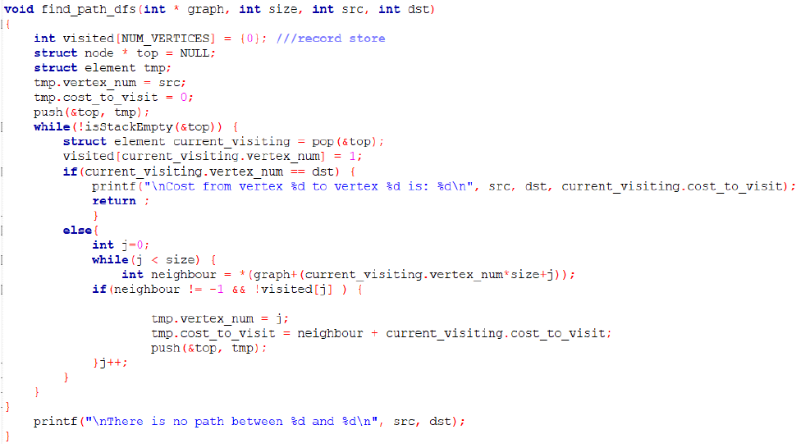

**Critical Analysis:**

This lab provides a comprehensive introduction to graph data structures, covering both weighted and unweighted graphs. The use of the C language for graph construction and manipulation enhances understanding of fundamental concepts. The tasks are well-structured, beginning with the completion of the adjacency matrix through the 'add_edge()' function, ensuring a hands-on approach to graph representation. The subsequent task involves implementing the Depth-First Search (DFS) algorithm for finding the cost of a path from a source to a destination vertex.

The strengths of this lab lie in its step-by-step progression, offering students a gradual learning curve. The emphasis on practical implementation, such as filling in the adjacency matrix and implementing DFS with a stack, reinforces theoretical knowledge. However, to further enhance the learning experience, the lab could benefit from additional explanations or comments in the code, providing more insights into the logic behind each step. Additionally, incorporating real-world examples or applications of graph algorithms could help students grasp the practical significance of these concepts.

In conclusion, this lab effectively covers essential aspects of graph data structures and algorithms in C. While it provides a solid foundation, further clarity in code comments and real-world examples would contribute to a more comprehensive learning experience. Overall, the lab succeeds in its objectives, offering students valuable insights into graph manipulation and traversal.